***MYSQL ASSIGNMENT 2***

1. ***C*reate a database named library and a table named books with the following columns:**

* **Id (INT,Primary key,Auto increment)**
* **title (VARCHAR(255))**
* **author(VARCHAR(100))**
* **year(year)**
* **genre(VARCHAR(100))**

create database library;

use library;

create table books(id int not null unique auto_increment,

title varchar(100),

author varchar(100),

year year,

genre varchar(100));

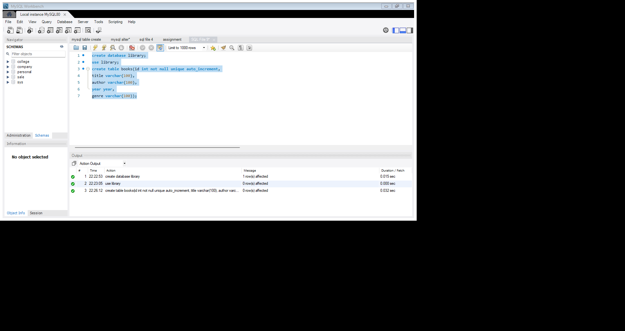

1. **Insert the following book records into the books table:**

* **"The Great Gatsby","F. Scott Fitzgerald",1925,** **"Fiction"**
* **"Pride and prejudice","Jane austen",1813,** **"romance"**
* **"to kill a mockingbird",harper lee",1960,** **"fiction"**
* **"1984","George Orwell",1949,** **"Dystopian"**
* **"Moby Dick","Herman Melville",1851,** **"Adventure"**

insert into books(title,author,year,genre)

values("The Great Gatsby","F.Scott Fitzgerald",1925,"Fiction"),

("pride and prejudice","Jane Austen",1913,"romance"),

("to kill a mockingbird","harper lee",1960,"Fiction"),

("1984","George Orwell",1949,"Dystopian"),

("Moby Dick","Herman Melville", 1951,"Adventure");

Select * from books;

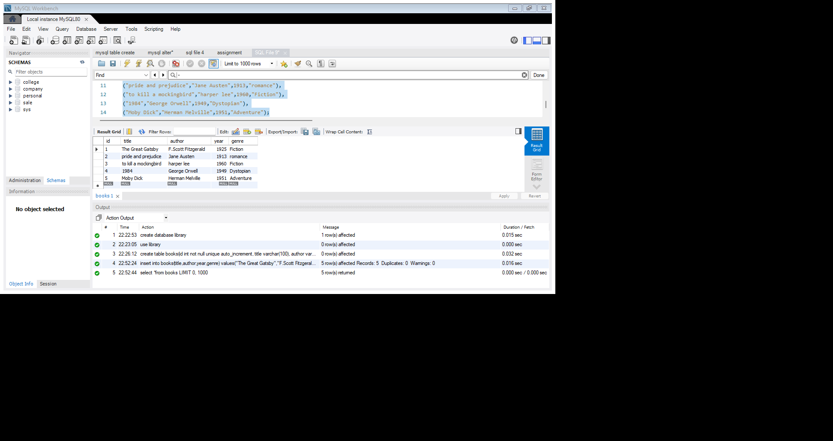



**3 .Write a query to select all books where the title starts with the letter 'T' using the LIKE operator.**

Select * from books where title LIKE'T%';

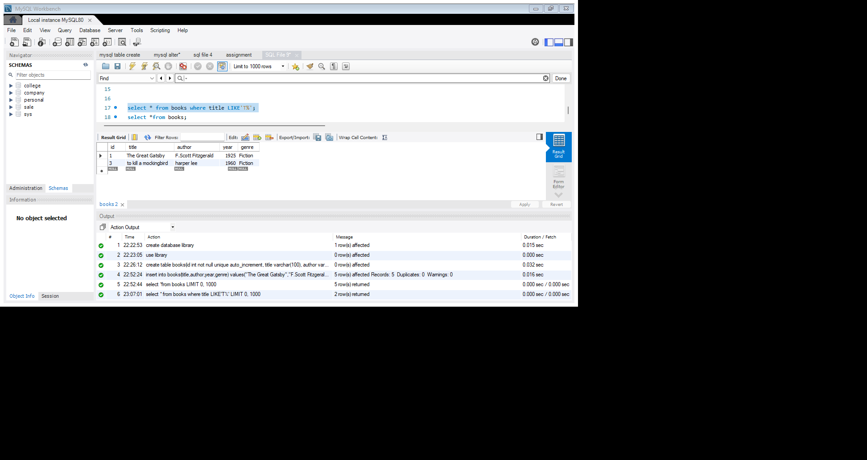



**4. Write a query to find all books where the author’s last name ends with 'son' using the LIKE operator.**

Select * from books where author LIKE’% son';

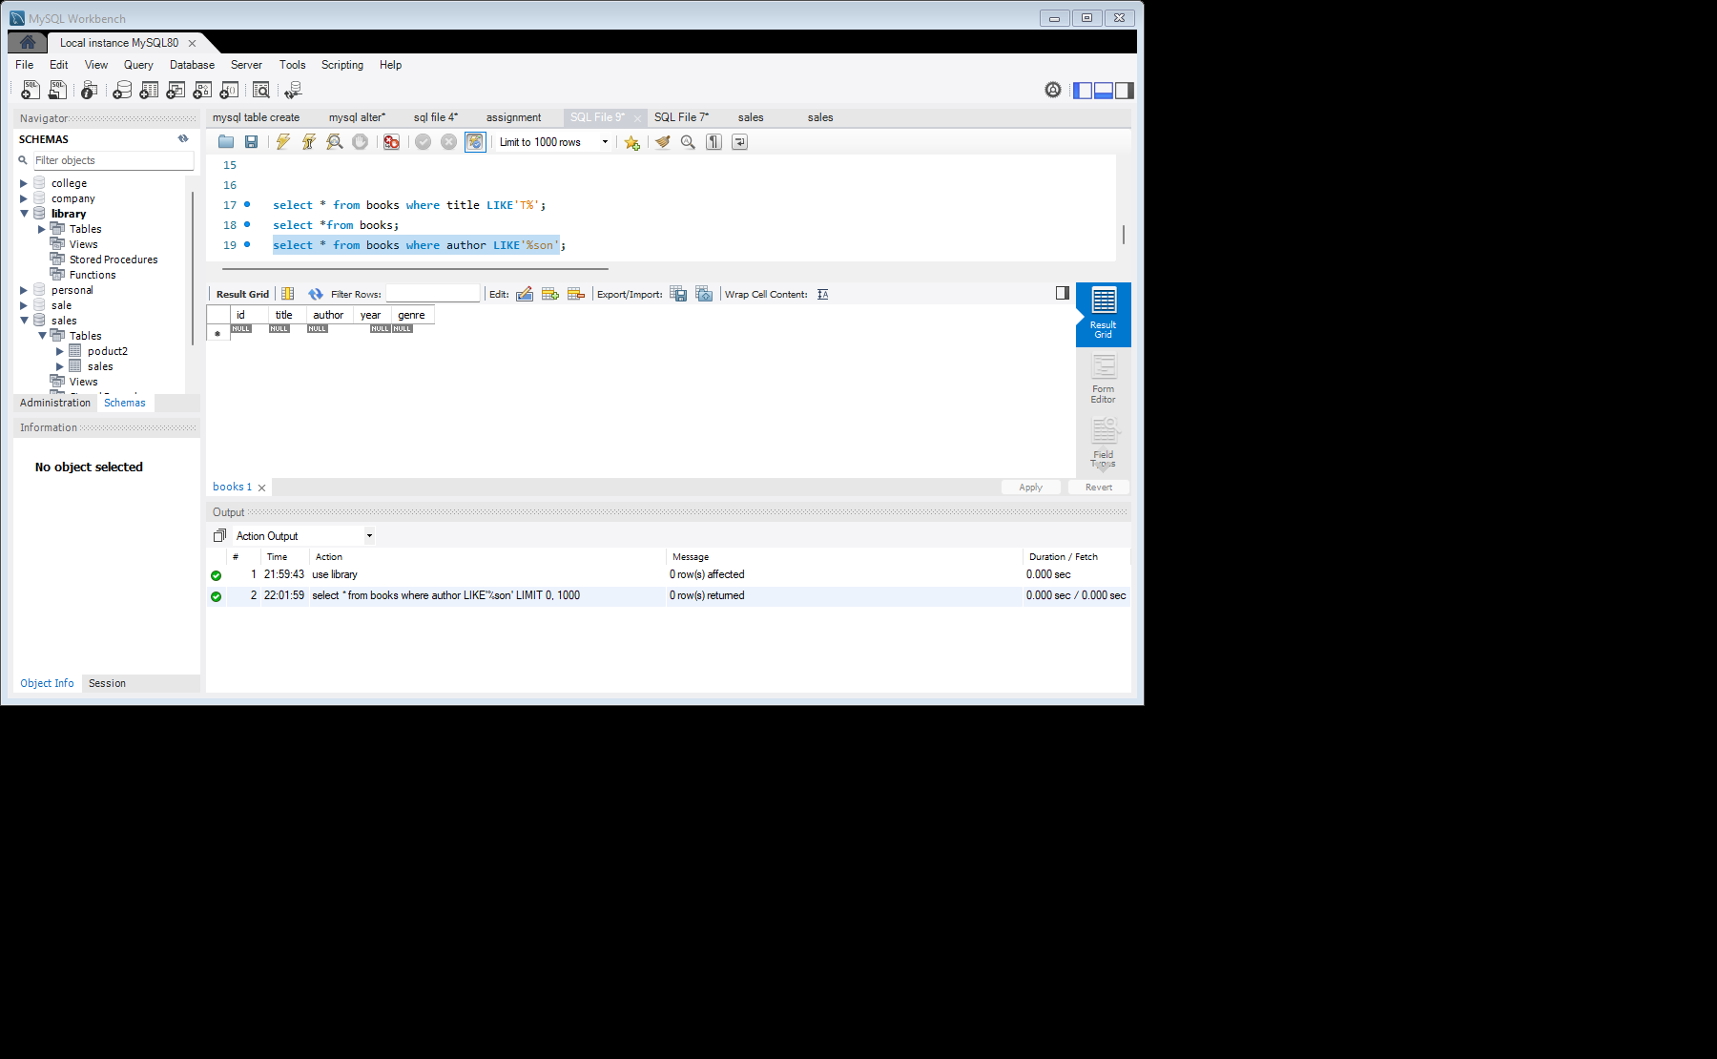



**5. Write a query to find all books where the title contains the word 'and' using the LIKE operator.**

Select * from books where title LIKE '%and%';

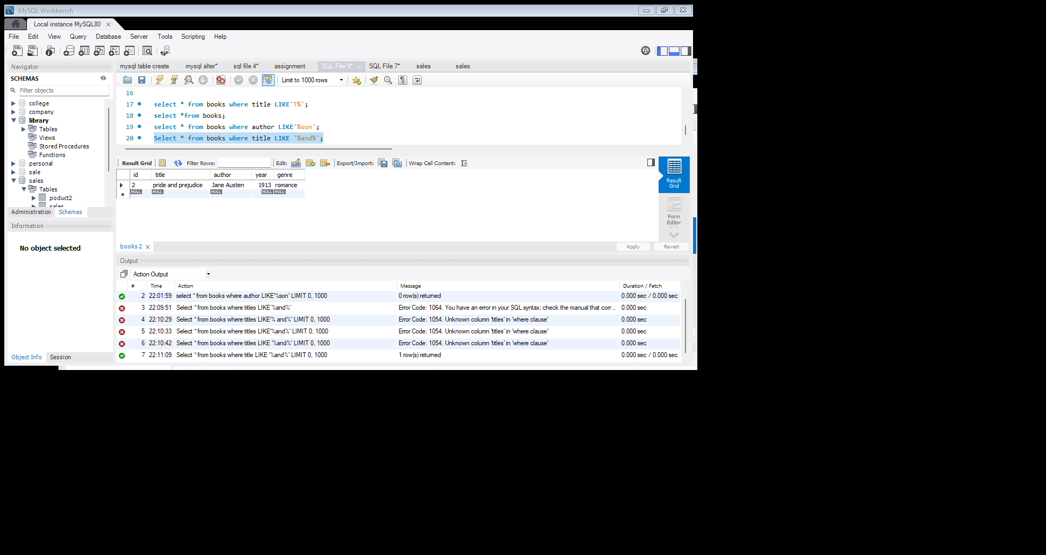



**6. Write a query to retrieve all books where the title ends with the word 'bird' using the LIKE operator.**

Select * from books where title LIKE '%bird';

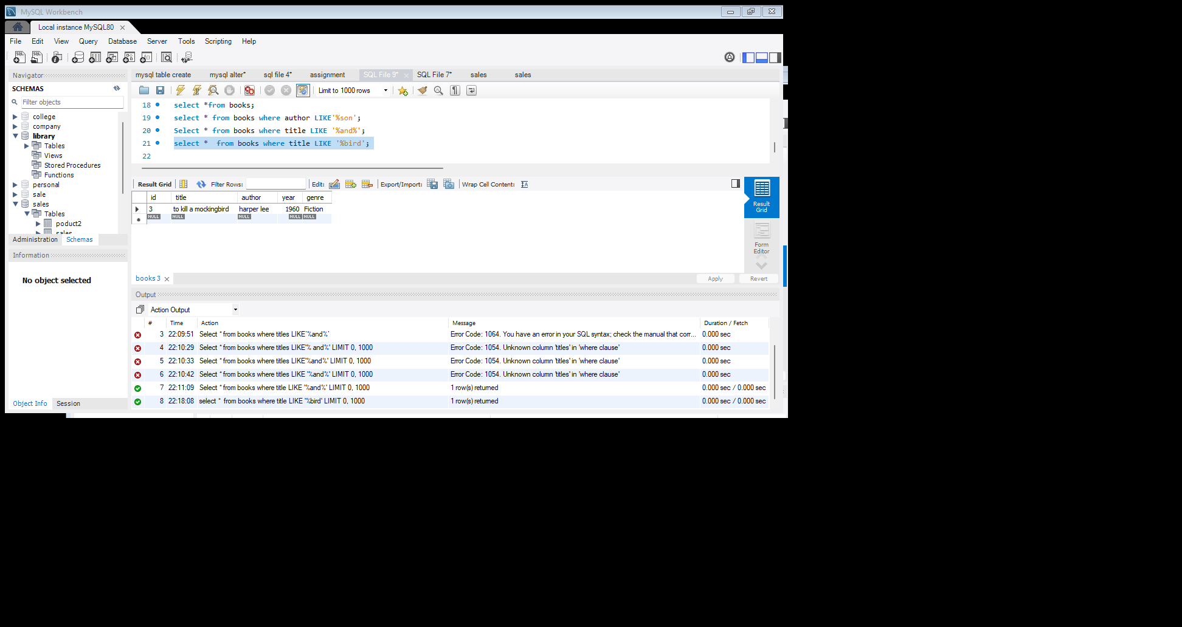



**7. Write a query to find all books where the title has exactly 3 characters using the REGEXP operator.**

Select *from books where title REGEXP'^. (3)$';

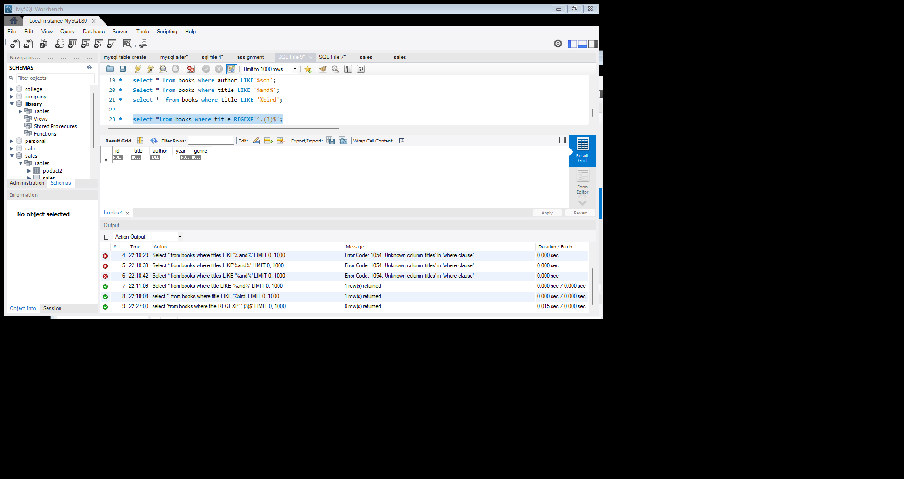



**8. Write a query to select all books where the title contains a number using the REGEXP operator.**

Select * from books where title REGEXP '[0-9]';

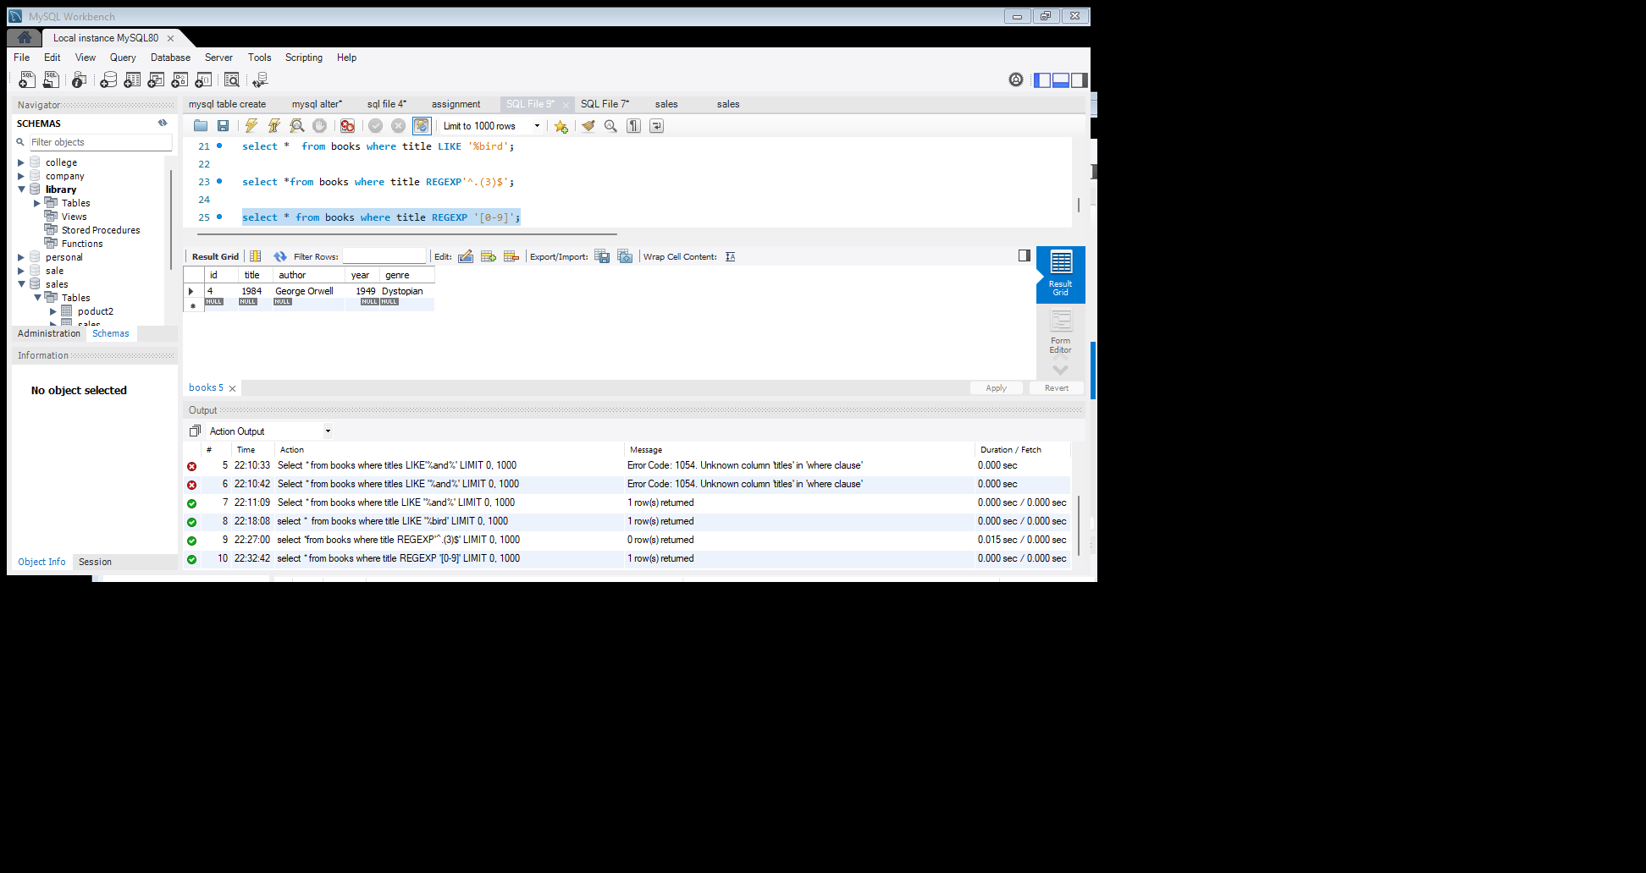



**9. Write a query to retrieve all books where the author’s name starts with any letter between 'A' and 'J' using the REGEXP operator.**

Select * from books where author REGEXP'^[A-Ja-j]';

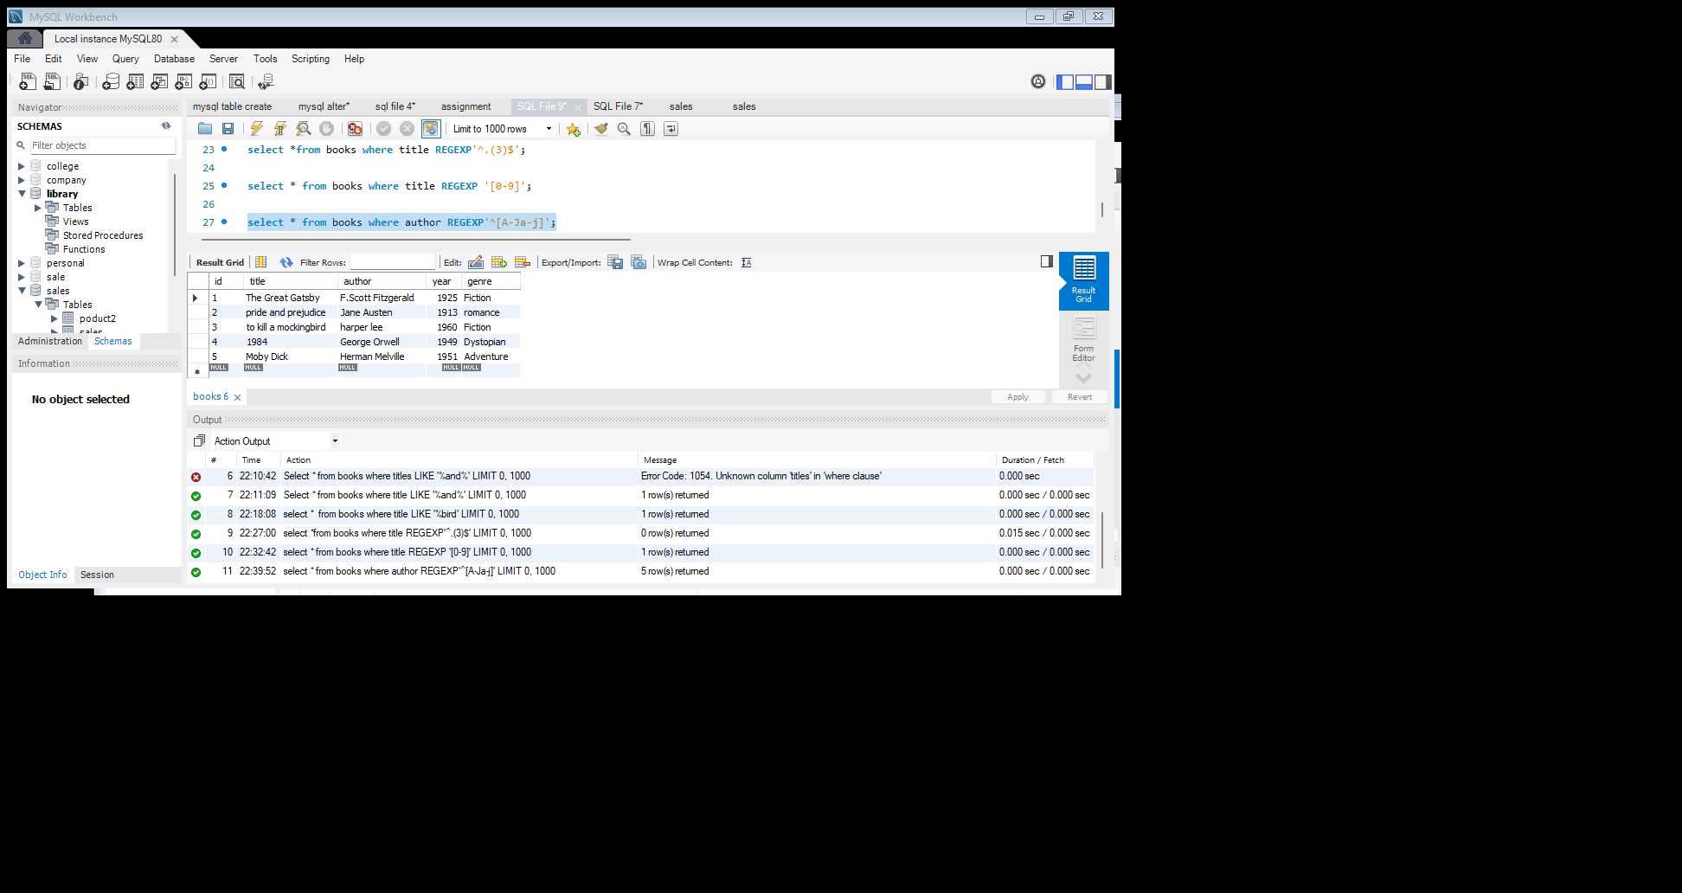



**10. Write a query to select all books where the genre is either 'fiction' or 'Adventure' using the REGEXP operator.**

select * from books where genre REGEXP'^(Fiction|Adventure)$';

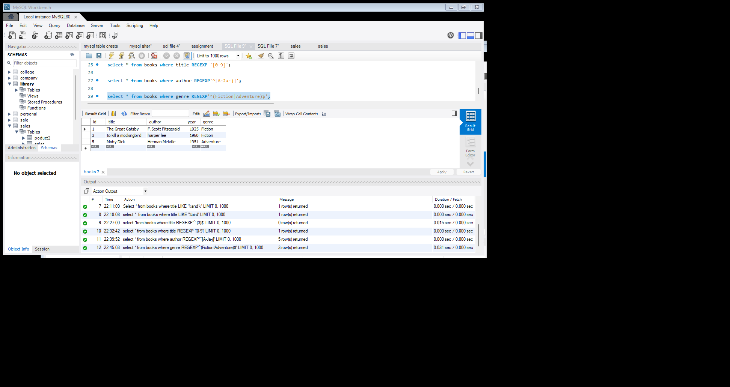



**11.Write a query to find all books where the title contains at least one uppercase letter using the REGEXP operator.**

Select*from books where title REGEXP'[A-Z]';

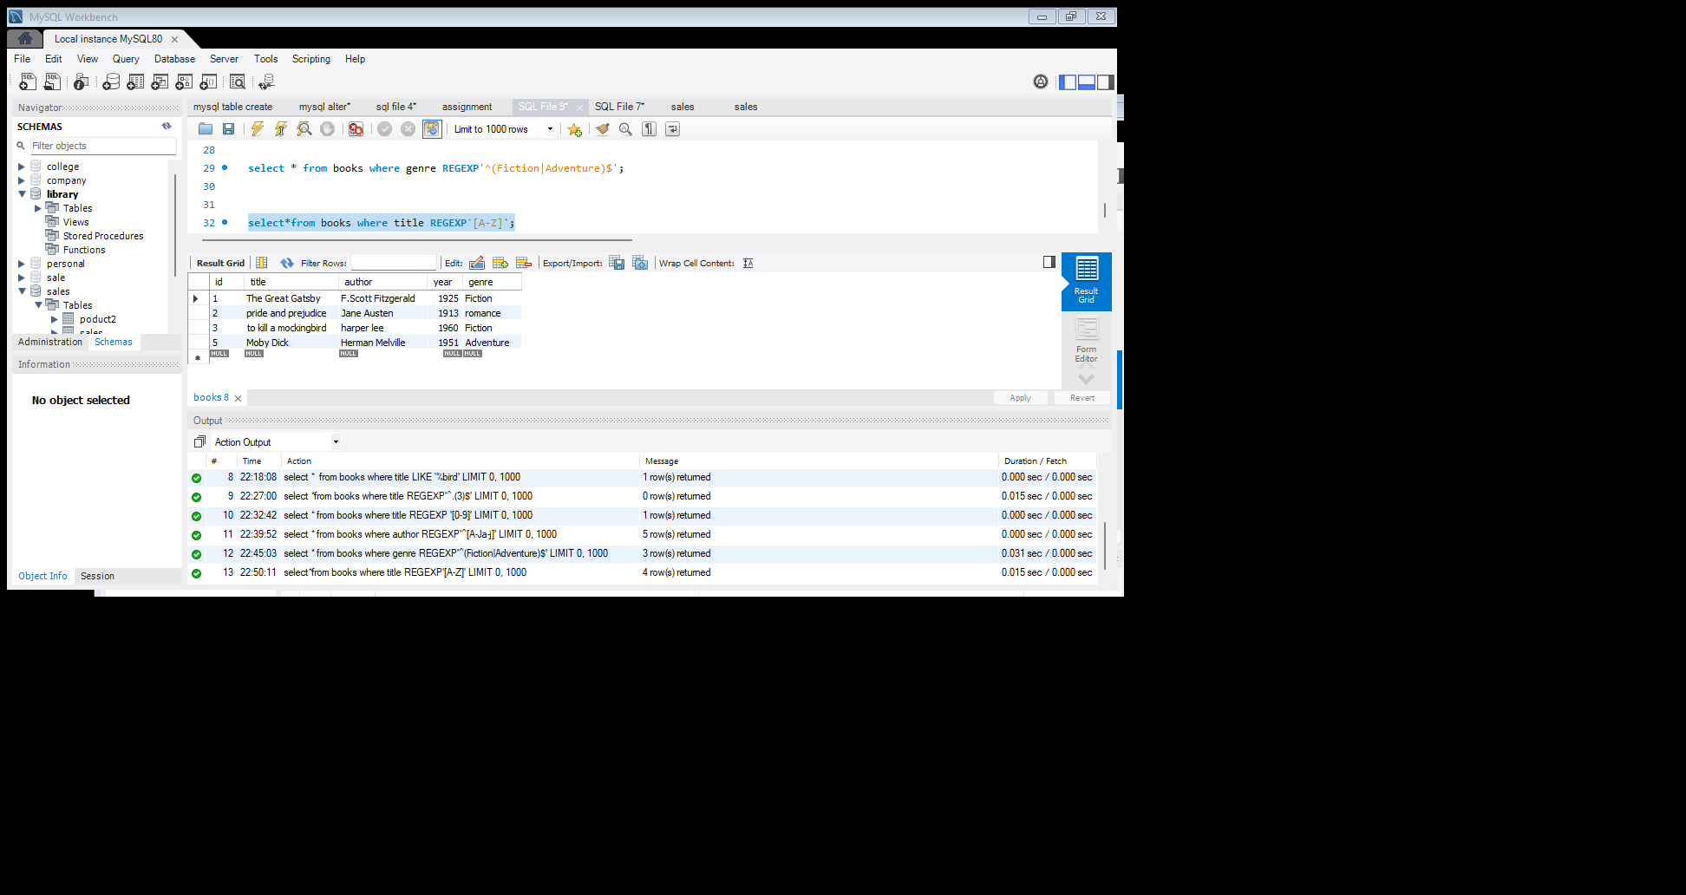



**12. Write a query to find all books where the year of publication is between 1800 and 1950 using the LIKE operator.**

Select * from books where year LIKE '18%'OR year LIKE'1950%';

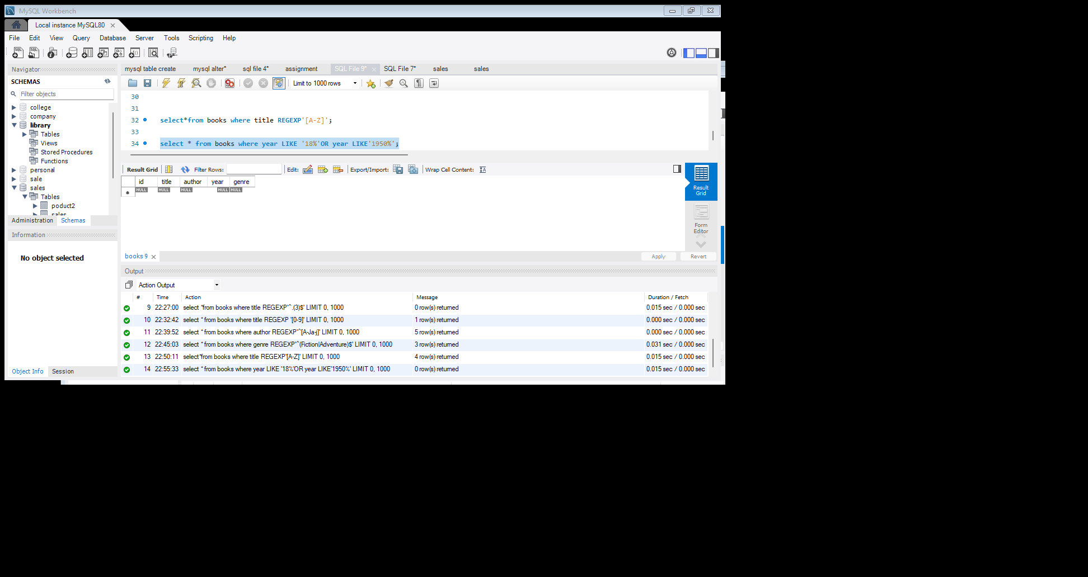



**13. Write a query to retrieve all books where the author’s name contains exactly two words using the REGEXP operator.**

Select *from books where author REGEXP'^[A-Z-z]+[A-Z-z]+$';

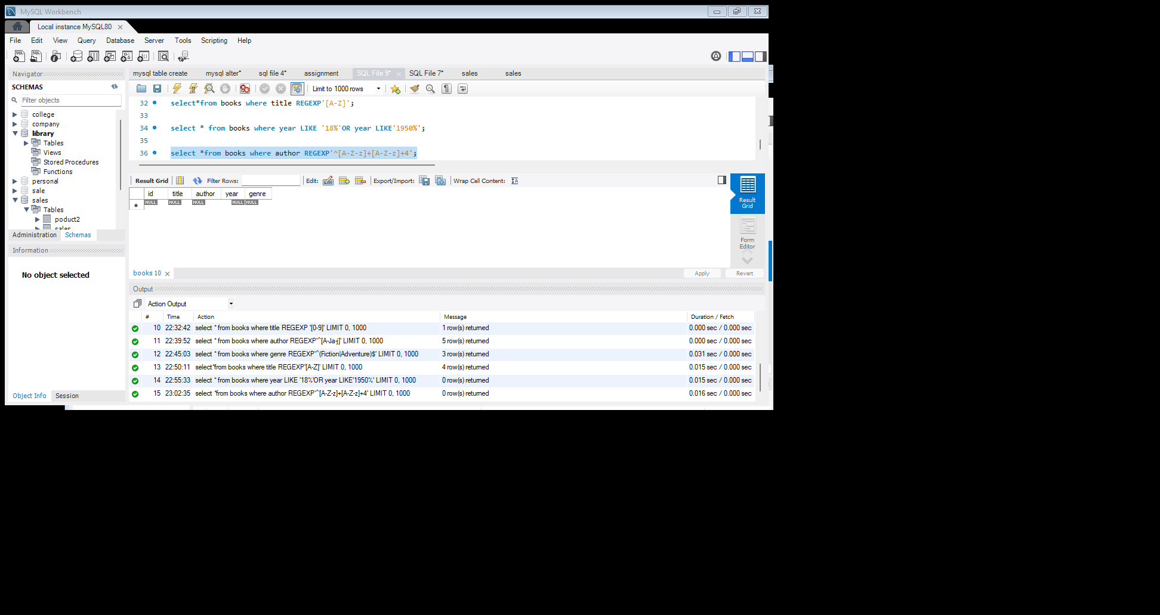



**14. Write a query to find all books where the title starts with the letter 'P' and contains exactly two words using the REGEXP operator.**

Select * from books where title REGEXP'[A-Za-z0-9]';

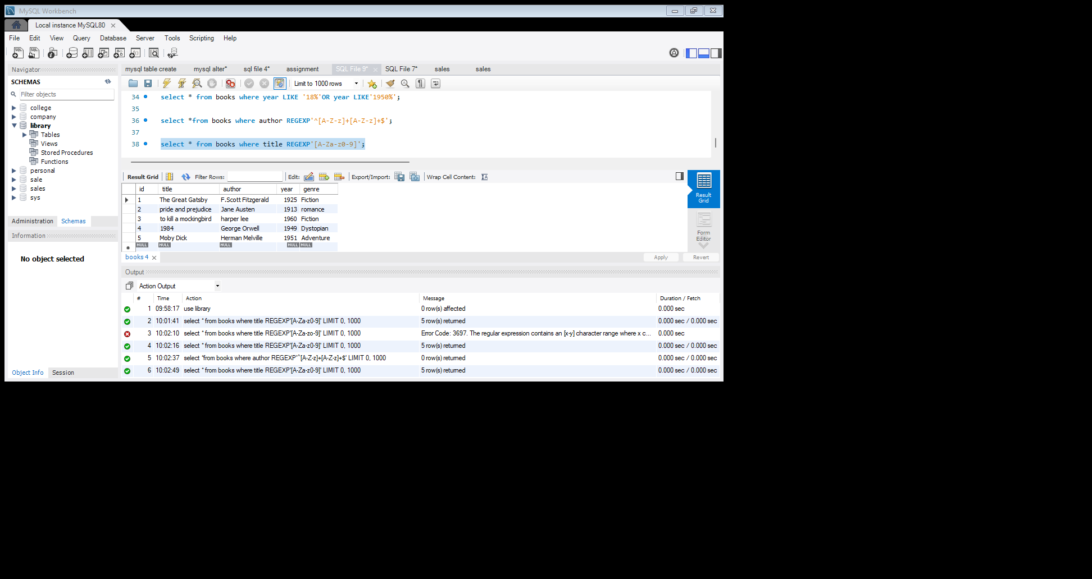



**15. Write a query to find all books where the title contains any special characters (e.g.,** **'!** **',** **'@',** **'#', etc.) using the REGEXP operator.**

Select * from books where title REGEXP'[[: punct:]]';

